FY 2019
Status of Activities by Aichi International Convention & Exhibition Center Co., Ltd. (AICEC)

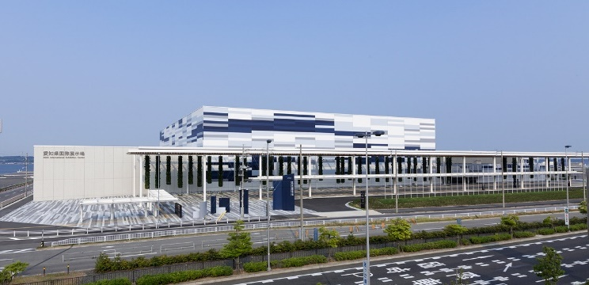
1. Business Outline
Aichi Sky Expo
Aichi prefecture is home to a world-class industrial cluster centered on the manufacturing industry. The prefecture offers an extensive transportation infrastructure including an international airport and a high-standard highway network. By taking advantage of the features of the prefecture, we aim to facilitate various interaction initiatives inside and outside the country through development and revitalization of the exhibition industry, and intend to promote the creation of new industries and the strengthening of existing industries, attracting business people from Japan and overseas to create and drive a new interaction and innovation base in the industrial metropolis, Aichi. In August 2019, Aichi Sky Expo (Aichi International Exhibition Center) opened on Chubu Centrair International Airport Island. Aichi Sky Expo is Japan’s first exhibition center directly connected to an international airport, and features the largest exhibition area in Japan, Japan’s only permanent bonded exhibition center and introduction of a 5G (fifth-generation mobile communication system) communication environment.
Facilities are operated adopting a concession system managed by Aichi International Convention & Exhibition Center Co., Ltd. (AICEC), a company established on January 19, 2018 by GL events SA (a French company) and Maeda Corporation. GL events SA, a constituent company, is a worldwide company that operates convention centers and provides comprehensive solutions and services to event organizers. With its global network, GL events SA operates 50 event facilities, including international convention centers, international exhibition centers, reception facilities and multi-purpose facilities. Maeda Corporation is a pioneer in the concession business in Japan and is also engaged in the operation of the concession business of eight toll roads throughout Aichi prefecture, including the access road to Aichi Sky Expo.
By introducing the concession system, Aichi Sky Expo intends to intensify its efforts to draw out the ingenuity and creativity of private entities and realize high-level services at low cost, resulting in the realization of “Good for Everyone” through improvements in convenience to companies and residents of the prefecture and users, securing profitability for private entities that conduct their business operations here and reducing government administrative cost.
GL events SA organized “Global Industrie” in France (Paris and Lyon), a large-scale international industrial exhibition proposed by French President Macron during his time as Minister of Economy, Industry and Digital Affairs. Taking advantage of GL events SA as a constituent company, AICEC looks to support organizing and holding a Japanese version of “Global Industrie.” The Company, in collaboration with Aichi prefecture, looks to promote initiatives to plan and organize trade fairs, exhibitions, and other events that attract a broad range of customers from Japan and overseas, and will, in such a way, present a new model for the operation of exhibition centers in Japan. In addition, the Company looks to utilize the global network of GL events SA to appeal to and attract overseas exhibition organizers.
A research study facilitated by Aichi prefecture aims to make Chubu Centrair International Airport and its surrounding areas an “MICE-focused international tourism city,” a base for holding important international conferences such as summit-level meetings and ministerial-level meetings and large-scale international exhibitions, trade fairs, and other events that create and drive business innovation. These initiatives aim to realize a unique “super city” status for Aichi while elevating its surrounding areas as the “world’s top international tourism city” incorporating cutting-edge technology and showcasing to the world a new spatial and temporal management style of a future city through the use of the latest technology. As one of the core bases in realizing the “super city” concept, AICEC, through its concession business plan with Aichi prefecture, has actively contributed to the realization of these aims since FY2019 and looks to continue to promote its initiatives in FY2020 and beyond.

2. Business Report
(1) Results of events held in FY 2019
- Number of events held
The number of events held at Aichi Sky Expo during the period from its opening (on August 30, 2019) to the end of March 2020 totaled 83. A breakdown of events by type: 7 concerts, 17 international conferences, 14 corporate events, 1 examination, 20 B-to-C exhibitions, 8 gaming events, 13 handshake events, 2 sporting events, and 1 B-to-B sales fair.
In addition to being used for exhibitions, Aichi Sky Expo is used for academic and professional examinations, gaming events, handshake events and sporting events that are unique to the latest exhibition centers. We will continue to explore our potential as an exhibition center.

- Main events
Date of Event | Name of Event | No. of Visitors
August 2019 | AICHI IMPACT! 2019 (opening event of the exhibition center) | 34,160
September 2019 | Wired Music Festival ’19 | 18,000
November 2019 | Nagoya Camping Car Fair 2019 Autumn | 21,078
November 2019 | 57th National Skills Competition/39th National Abilympics | 187,470
December 2019 | FIELD STYLE JAMBOREE 2019 | 42,000

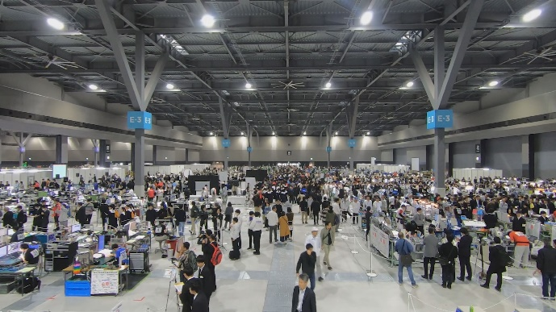
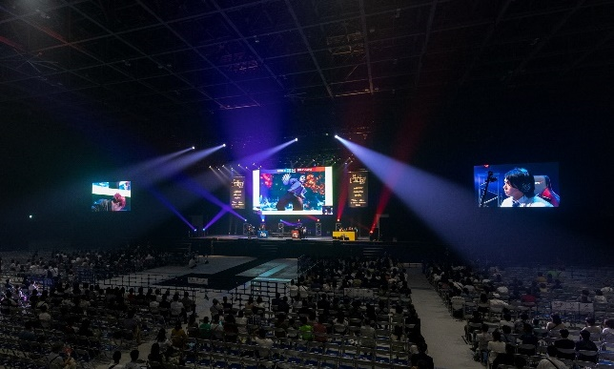
57th National Skills Competition

AICHI IMPACT! 2019

- Occupancy rate of exhibition halls
The exhibition halls occupancy rate throughout the year was 24.0%. The low figure for March was due to the impact from the spread of the novel coronavirus.
 | Aug. | Sep. | Oct. | Nov. | Dec. | Jan. | Feb. | Mar. | Total
Occupancy rate (%) | 4.8 | 31.2 | 27.6 | 51.0 | 15.7 | 26.9 | 10.4 | 0.3 | 24.0

- Number of visitors
The total number of visitors in FY 2019 was 675,799. On a monthly basis, November was the highest figure with 233,445 visitors, however, in March, there were no visitors due to the impact from the spread of the novel coronavirus.
 | Aug. | Sep. | Oct. | Nov. | Dec. | Jan. | Feb. | Mar. | Total
No. of visitors | 15,990 | 140,320 | 85,546 | 233,445 | 98,648 | 88,490 | 13,360 | 0 | 675,799

(2) Actual Income and Expenses
In FY 2019 (from the opening in August 2019), revenue from the main business, i.e., total usage charges for exhibition halls, conference rooms, equipment, etc., totaled 651 million yen, revenue from incidental business, i.e., total usage charges for parking lots totaled 65 million yen, revenue from food and beverage sales totaled 14 million yen, and revenue from other services totaled 47 million yen. Total operating revenue was 777 million yen.
Apart from the main business and incidental business, for the discretionary business, revenue from food and beverage sales totaled 1 million yen and revenue from other services also totaled 1 million yen.
On the other hand, the total operating cost of the main business and incidental business was 720 million yen. The breakdown was 236 million yen for the cost of maintenance and management of the facilities, 95 million yen for the cost of events, 25 million yen for the cost of various activities, 352 million yen for the cost of general administration, 8 million yen for the cost related to parking lots, and 4 million yen for the cost related to foods and beverages. Thus, operating activities, other than the discretionary business, for FY 2019 resulted in a surplus of 57 million yen.

Monthly Results of Main Business and Incidental Business (Unit: million yen exclusive of taxes)
 | Aug. | Sep. | Oct. | Nov. | Dec. | Jan. | Feb. | Mar. | Total
Operating revenue | 0 | 122 | 132 | 235 | 82 | 101 | 27 | 78 | 777
Operating cost | -5 | -149 | -108 | -87 | -117 | -97 | -80 | -77 | -720
Operating profit and loss | -5 | -27 | 24 | 148 | -35 | 4 | -53 | 1 | 57

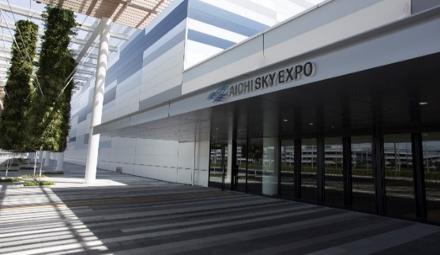
3. Details of Main Activities
Main Entrance
(1) Administrative management operations
Main operations include the development of business plans and the management of annual plans as well as the implementation of the relevant monitoring. Accounting operations include budgetary control and the preparation of financial statements, and general affairs operations include the management of documents and ledgers. This also includes adjustments to operations, information sharing and management of company-related documents and agreements.
The Company also conducts oversight and review of self-monitoring work, preparation of annual management plans and other related documents, and manages work-related submissions.

(2) Facilities maintenance and management operations
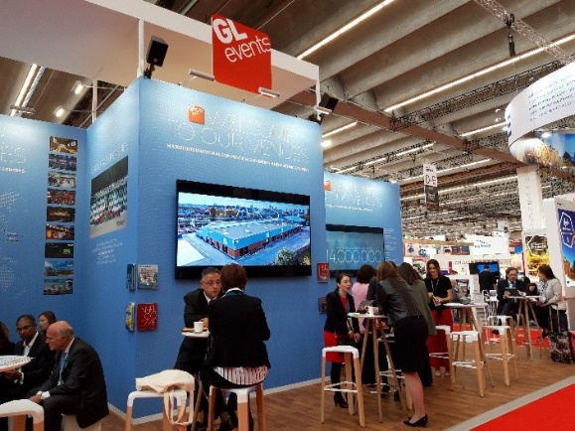
(i) Marketing and promotion operations
IMEX Frankfurt
As part of promotion for the opening, based on an entrustment contract by Aichi prefecture, the Company conducted wide-area campaign activities at major stations, and the placement of advertisements inside trains and the airport from July to September to disseminate information about Aichi Sky Expo. For the organizers of exhibitions and event promoters, the Company made efforts to actively facilitate the use of these facilities through the dissemination of newsletters, insertion of advertisements in magazines dedicated to MICE, participation in MICE trade fairs where domestic and foreign industry stakeholders gather, UFI (Union des Foires Internationales), which is the world’s largest exhibition industry organization, and the like. With regard to overseas events, the Company participated in IMEX Frankfurt (the world’s largest MICE trade fair), UFI Congress Bangkok 2019, China International Import Expo (Shanghai) and IBTM World 2019 (a trade fair dedicated to MICE, Barcelona).
In addition to the constant dissemination of detailed information and access to the facilities, schedule of upcoming events and other latest information on the website of Aichi Sky Expo and SNSs and through PR videos, the Company displayed banner advertisements on the website of Mash Media Group Limited, a publisher in the UK that issues “Exhibition World,” an MICE-specific magazine and on the website of IBTM China, a trade fair dedicated to MICE.
Overseas Banner Advertisement

(ii) Attraction and marketing operations
The Company held weekly meetings for the purpose of reporting activities, sharing action schedules, checking monthly numerical progress, etc. While closely collaborating with Aichi prefecture and related organizations, the Company worked on the collection and sharing of information. The Company also worked on attracting events that would contribute to the development of the region, taking advantage of the direct connection to the airport, a facilities feature, and the presence of an industrial cluster, a feature of Aichi prefecture.
In addition, the Company conducted attraction activities for events in a manner unique to AICEC with the French company GL events SA acting as a constituent company. For example, the Company succeeded in attracting an e-sports event held in France (Rainbow Six Siege Pro League Final) for the first time to Japan.
Due to the fact that FY 2019 was the first fiscal year following the opening and the impact from the novel coronavirus at the end of the fiscal year, attraction activities targeting overseas events did not achieve satisfactory results, however, the Company will continue to actively attract overseas exhibition organizers, etc., to hold events, using the global network of GL events SA.

(iii) Reservation management, use permits, fee collection, etc., and event organizing support operations
In order to accurately manage reservations, the Company has introduced a system to make possible the entry of application form data into the reservation management system and the management of the process for the issuance of permits. The system makes it possible to allow for accurate management of available periods. Available periods and facilities can be accurately confirmed by the system in order to ensure fair and equal use. In addition, we comply with the relevant laws and regulations including the Prefectural Ordinance on Aichi International Exhibition Center, and make decisions on users while ensuring fair and equal use taking into account the purpose of the establishment of these facilities. As part of operations to support organizing events after the issuance of a permit for use, the Company provides advice to users on how to effectively use the venue, and lends equipment as appropriate, and otherwise assists organizers in smoothly organizing events.

(iv) Facilities maintenance and management, traffic congestion countermeasures, and disaster prevention and disaster countermeasures operations
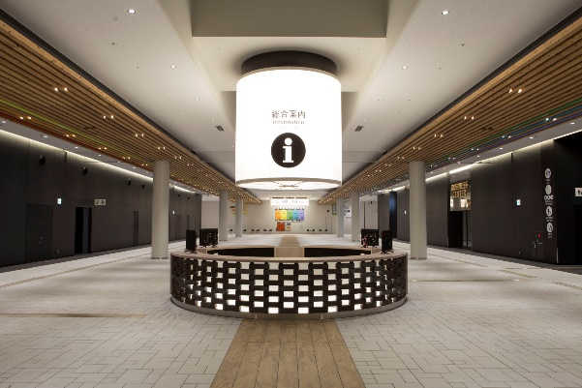
- Facilities maintenance and management operations
Information Center
The Company conducted maintenance and management operations for buildings, facilities, equipment, etc., and outdoor facilities, security operations, hygiene control and cleaning operations, and information center operations in accordance with the annual operation process schedule while taking various events into account. The appropriateness of each operation was confirmed.

- Traffic congestion countermeasures
The Company took countermeasures for traffic congestion while sharing information and collaborating with Central Japan International Airport Co., Ltd., Nagoya Railroad Co., Ltd., Aichi Road Concession Co., Ltd., and other related transportation organizations. In particular, Nagoya Railroad Co., Ltd., increased the number of services and the number of cars per train, and did more to respond at the time of events, which contributed greatly to improving convenience in access for organizers, exhibitors and visitors. Moreover, while collaborating with organizers, the Company appropriately assigned traffic guards around the facilities as a countermeasure for traffic congestion.

- Disaster countermeasures operations
The Company has prepared an emergency management manual, emergency response flow, evacuation route map, etc., and takes countermeasures for disasters. The Company also appropriately conducts disaster prevention drills twice a year. In addition, the Company prepared for and checklisted disaster supplies and appropriately manages them, and executed a memorandum of understanding with nearby entities with respect to the procurement of supplies at the time of a disaster.

(3) Incidental business operations
(i) Parking lot operations
Parking lot use shown in the table below.
 | Aug. | Sep. | Oct. | Nov. | Dec. | Jan. | Feb. | Mar. | Total
No. of cars parked | 1,193 | 20,625 | 9,894 | 13,076 | 16,743 | 9,528 | 1,712 | 77 | 72,848
With regard to the operation of parking lots and traffic-related measures for the parking lots and surrounding area, the Company ensures opportunities for timely information sharing and consultations with Central Japan International Airport Co., Ltd., and other nearby entities and local law enforcement, thereby handling these issues in a collaborative manner.

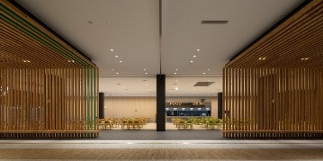
(ii) Operation of foods and beverages, shops and other convenience facilities for users
Food Court
On days of events, the Company operates a food court and shops as well as a business center that provides services including photocopying, courier deliveries, etc., so that visitors of events can spend their time comfortably and effectively.

(iii) Support for exhibitions utilizing the functions of the comprehensive bonded area
Before the opening, the Company completed procedures to join the Chubu Centrair International Airport Comprehensive Bonded Area and put in place a system to accept requests for bonded exhibitions. In FY 2019, exhibitions utilizing the functions of the comprehensive bonded area were not actually held, however, the Company further improved and supplemented the guidance materials and promoted efforts to facilitate use.

(4) Demand creation through public-private collaboration operations
Operations to facilitate demand creation through public-private collaboration include the business for regional promotion, the business to support organizing events (Destination Management Company (DMC) business) and the business to plan and organize exhibitions, etc., which were all conducted through “Aichi Sky Expo Promotion Organization,” an organization based on public-private collaboration that is comprised of Aichi prefecture and AICEC.
In order to create demand for Aichi Sky Expo through the unified efforts of the entire region, at the end of FY 2018, local economic organizations, universities, transportation-related entities, governmental agencies, etc., set up a “Conference for Demand Creation for Aichi Sky Expo.” The conference was also held in FY 2019 and opinions were exchanged on regional revitalization centering around Aichi Sky Expo through panel discussions, facility tours, networking by participants (interaction session), etc.

(i) Business for regional promotion
A review was conducted by Aichi prefecture, AICEC and related organizations, etc., collaboratively with respect to regional promotion that would result in a higher appeal and attraction effect. For specific activities, the Company worked to further promote the use of the exhibition center through participation in the executive committee for the opening event “AICHI IMPACT! 2019” and use of a subsidy granted to promote use of the exhibition center.
“AICHI IMPACT! 2019,” an international e-sports competition and live entertainment festival invited top domestic and foreign players as well as entertainers and others that attracted about 35,000 people, and related video distribution recorded a viewing population of about 170,000 people, while access to the official Twitter account was about 6.4 million.

(ii) Business to support organizing events (DMC business)
Aichi prefecture, AICEC and related organizations conducted a review on what would be the appropriate level of support by understanding the problems and needs of entities, etc., who intend to plan and organize events, and access-related measures were taken and arrangements for advertising media were made.
The advertising media has been used since FY 2020, which is linked to the attraction of events and support in organizing events.

(iii) Business to plan and organize exhibitions, etc.
Aichi prefecture and AICEC conducted a review on exhibitions that would take advantage of the industrial features of Aichi prefecture. Based on the results of the review, basic research was conducted to plan and organize a new exhibition, i.e., a Japanese version of “Global Industrie.”
Moreover, following the “Agreement for Promotion of Exhibition Industry Between Aichi Prefecture, Japan and GL events SA,” which was executed in March 2018, the “Memorandum of Understanding for Launch of New Industrial Exhibitions in Aichi Prefecture Between GL events and Aichi Prefecture” was executed in June 2019. Furthermore, in the same month, the road map for collaboration between Japan and France that was issued by the governments of Japan and France also mandated support for launching a Japanese version of “Global Industrie.” Based on these movements, AICEC will make every effort to organize a Japanese version of “Global Industrie.”
And, while making such efforts, the Company will take the initiative in the realization of new exhibitions.

(5) Discretionary business
For the first year following the opening, while the number one purpose was to meet the basic needs of the users of the exhibition facilities, the Company promoted the provision of a system of cleaning and waste disposal services, and the provision of food truck services to respond to a variety of meal-related requests, etc. In connection with the promotion of the discretionary business, the Company will proceed with work while confirming that there is no risk of adverse effects on the main business.
From FY 2020 onward, the Company will steadily make preparations so that the Company can organize events at Aichi Sky Expo.

(6) Other
- Countermeasures for the novel coronavirus (including details for FY 2020)
In order to take facilities-related countermeasures for the novel coronavirus, the Company placed thermographic temperature measurements, strengthened the cleaning of areas where there is a risk of infection within the facilities, installed clear panels for face-to-face interaction, made disinfection solution available at entryways and exits, put up posters to draw attention to wearing a mask, etc., and posted the indication for those who wait for the use of restroom facilities, the indication to prohibit seating without spacing, the indication to call for ensuring social distancing, etc., to avoid the three Cs. The Company also actively recommends and raises awareness about the use of the COVID-19 Contact-Confirming Application (COCOA) in collaboration with government agencies, etc., and has registered as “Safety Relief Declaration Facilities,” which has been promoted by Aichi prefecture. Moreover, in order to take system-related measures, the Company formulated the facilities’ original “COVID-19 Infection Control Guidelines” ahead of other exhibition centers and has published those Guidelines on the website of Aichi Sky Expo. In line with those Guidelines, the Company formulated guidance on the implementation of infection prevention countermeasures to show specific measures to be taken by organizers at the venue of events. Furthermore, in case of occurrence of infections, the Company has established a collaboration system with local medical institutions and healthcare centers.

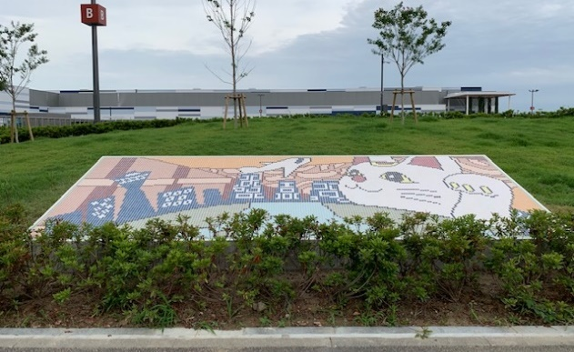
- Donations, etc., from various organizations
Tokonameyaki Tile Art

The operation of Aichi Sky Expo has been supported by local people, and donations, etc., were made by the following entities (honorifics omitted) during FY 2019.
2019 | Jul. | Tokonameyaki tile art (Young Entrepreneurs Group of the Tokoname Chamber of Commerce & Industry)
 | Aug. | Wheelchairs (The Rotary Club of Tokoname, Tokoname Lions Club), Sanshugawara Onigawara objet (Aichi Prefecture Clay Roof Tile Industrial Association)
 | Dec. | Wheelchairs (The Rotary Club of Nagoya Southeast)

